***GRAMMAR:*** 2 weeks ago, I told you: “In this unit,we have two different grammatical structures, a quite easy one (Future) and a little bit harder one (First Conditional). So now let´s start with the ***First Conditional***

***We use it to talk about things that will probably happen in the future.***

Remember: we have 2 verbs: look at the tense you have to use for each of them:

- Use the **Present Simple** with the verb that goes in the ***condition*** (**if**= si….)

- Use the **Future** with the verb that expresses the ***result***

***Examples: If*** *you buy flour, we will make a cake. = We will make a cake* ***if*** *you buy flour.* condition result result condition

***If*** *you study, you will pass = you will pass* ***if*** *you study.*  condition  result result condition

So you have to learn this structure:

***If + present,*** ***will / won´t + infinitive = will / won´t + infinitive if + present***

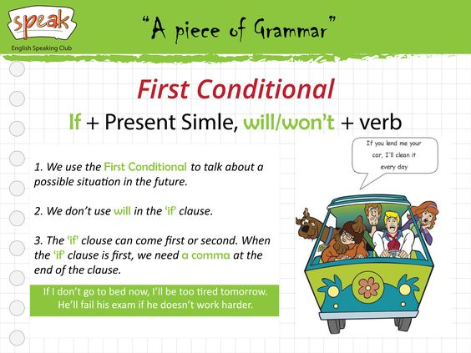

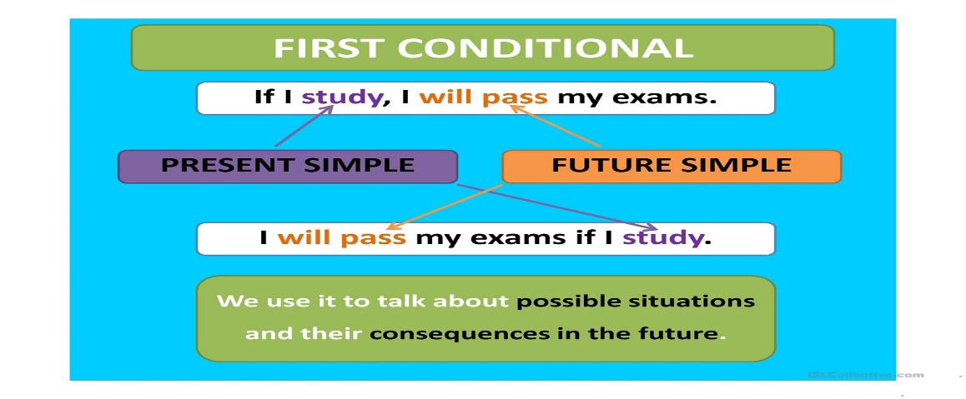

Here are 2 good tutorials you can watch on Youtube, to reinforce the First Conditional

<https://www.youtube.com/watch?v=yDZaMZphLjk&ab_channel=TeacherPhilEnglish>

<https://www.youtube.com/watch?v=lyYc8fNU5DM&ab_channel=RaniaEnglish>

I want to check if you understand or not the First Conditional. So please do exercise 10 pg 113 SB (there are only 5 sentences) on your notebook and send it to me (I will tell you if you did them right or wrong). Send it as soon as posible (ASAP) to realise if you understand it.

Then after checking that you understand this new grammatical structure, you have to do these exercises: Ex.9-10 pg 113 SB (you can do them on the SB, using a pencil) and pg 75 WB.

Don´t send them, I will give you the keys (right answers) at the end of May (Friday 29th May).

***Advance your language Section***

Do ex. pg.115 SB (Don´t send them, I will give you the keys)

***Vocabulary:***  **Adjectives of personality.**

Study these new adjectives (I said “new” but you already know most of them):

*Kind* (majo); *strong* (fuerte); *quiet* (callado); *lazy* (vago); *evil* (malvado); *calm* (tranquilo); *clever* (listo); *nervous* (nervioso); *serious* (serio); *confident* (seguro de sí mismo); *athletic* (deportista); *funny* (gracioso); *friendly* (amable); *shy* (tímido); *weak* (débil): *unfriendly* (antipático); *hard-working* (trabajador)

Do ex. 2 (on your notebook) and ex.3 (on the book, using a pencil) pg.116, and ex1-2-6- pg 77 WB (Don´t send them, I will give you the keys)

I will do ***Advance your language*** pg.116 SB for you. Simply read it and pay attention to these words, formed combining 2 adjectives: *blue-eyed* (de ojos azules); *curly-haired* (de pelo rizado); *good-looking* (guapo, atractivo); *well-dressed* (bien vestido); *world-famous* (mundialmente famoso).

***Speaking***: pg.117 Please notice the difference between these 2 questions (they are very similar, but the meaning is different):

-*What does he look like?* (= ¿Cómo es él físicamente?) Possible answer: He is short and blue-eyed

- *What is he like?* (= ¿Cómo es él, su personalidad?) Possible answer: He is clever and friendly.

Now do ex.7 pg.117 SB on the book, using a pencil.

ex.7 pg.80 WB (Don´t send them, I will give you the keys)

***Check your Progress*** Do ex.1-2-3-4-5 pg.79 WB (Don´t send them, I will give you the keys)

***Writing*** pg 118 This writing is not compulsary, I mean, do it and sent it to me **voluntarily.** You simply have to write an e-mail, describing a friend. Use: *To*… and then a mail address, From… and your mail address, *Dear*… for the greeting, *Bye for now* at the end before your name. Use the model in ex.3.

Summary: Send me ex. 10 pg 113 SB and the writing ( this one is voluntary)

I will send the keys of all the other exercises at the end of May (Friday 29th May).

Take good care of yourselves!!!!

Montse.